**Name: MUHAMMAD HUZAIFA**

**Roll No: BIT-24S-017**

**PYTHON LOOPING TASKS**

**Task 1:**

Print numbers from 1 to 10 using a for loop.

**Program:**

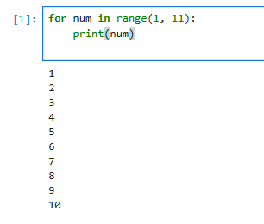

**Task 2:**

Print all even numbers between 1 and 20 using a while loop.

**Program:**

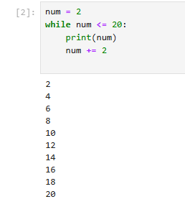

**Task 3:**

Calculate the sum of numbers from 1 to 100 using a loop.

**Program:**

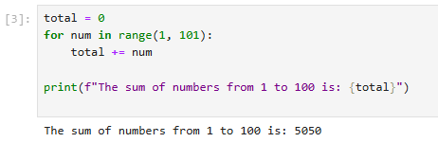

**Task 4:**

Print the multiplication table of 5 using a loop:

**Program:**

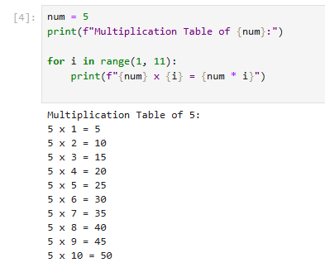

**Task 5:**

Find the factorial of a given number using a for loop.

**Program:**

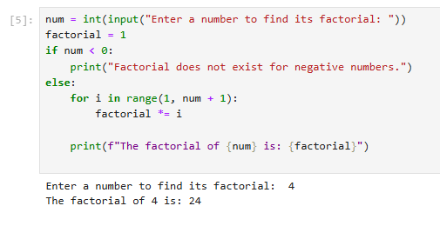

**Task 6:**

Create a list of numbers and print only the odd numbers using a loop.

**Program:**

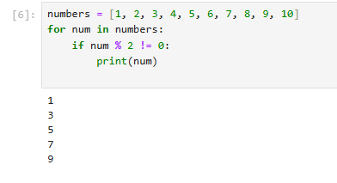

**Task 7:**

Iterate over a list of fruits and print each item.

**Program:**

